**Weekly Report 10/14**

**MSiA-400 Group 1** : Ellen, Henry, Ishu, Enzo

Tasks Accomplished:

* Created a slack channel for communications.
* Created a shared google doc as our PM tracker/weekly updates.
* Connected to the NU resource servers, such as GlobalProtect and etc.
* Downloaded the data base interface (PGADmin) and the data sets.
* Uploaded the data sets into the data base schema and shared access with each member (literally took hours... thank you Ellen!)

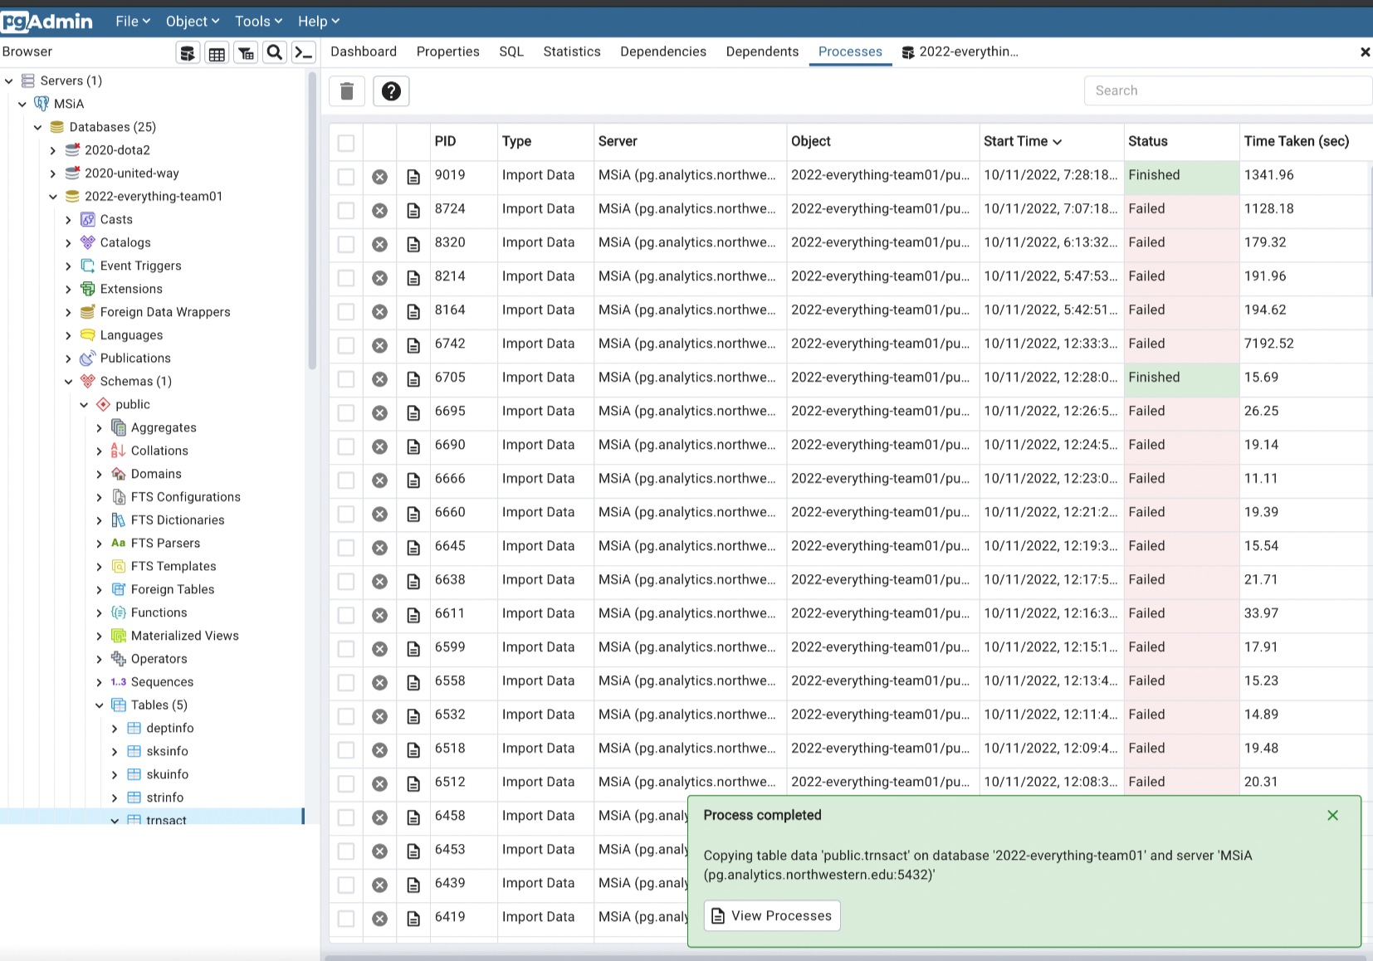

* Explored the data sets and understood the complexities of them.

Plans for Next Week:

1. Further look into the five data sets
2. First-stage data cleanning
3. Coming up with topics of interest